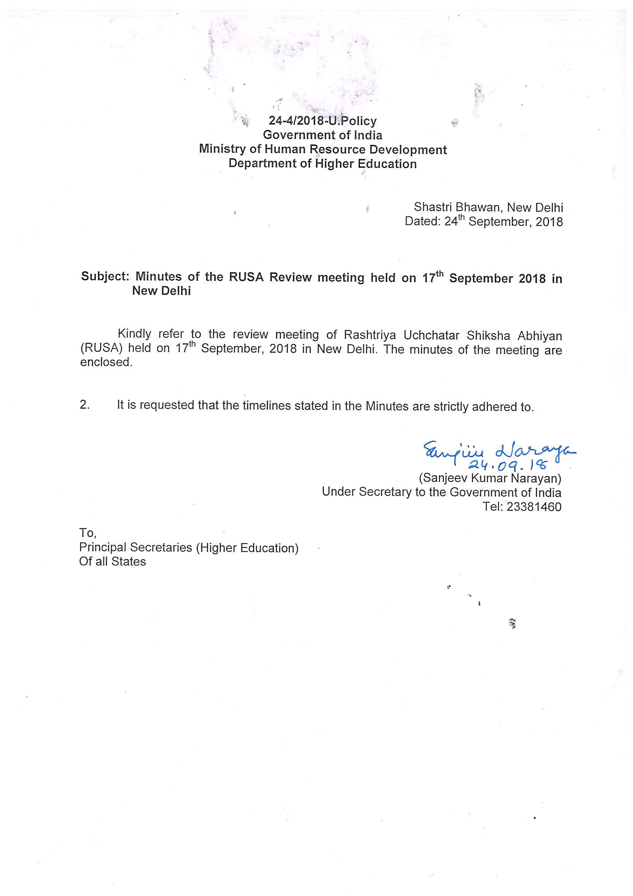

RUSA Review Meeting
17th September 2018

A meeting with State Principal Secretaries/ Secretaries (Higher Education) under the chairpersonship of Joint Secretary (Higher Education) and National Mission Director (RUSA) was held on 17th September, 2018 to review the progress and performance of RUSA since inception.

2. At the outset, the NMD welcomed all the participants. During the review, the following issues were discussed:

- Utilization of central grants under RUSA 1.0: It was observed that there had been significant improvement in the utilization of central grants over the last 4 months and many states had been able to achieve good progress in utilizing central grants. All the States were requested to fully utilize the central grants released to them till 31st December 2017, by the 30th September 2018, failing which the States would be requested to surrender the balance funds with interest and no further fund release would be done for the State. The details of the pending central share as committed liabilities for RUSA 1.0 are at Annexure I.
- Performance of Universities and Colleges under infrastructure grants: Based on the utilization certificates submitted by the beneficiary universities and colleges, it was noticed that a large no. of universities and colleges had not yet utilized 50% of resources released to them. It was decided that these institutions would be reviewed separately towards the first week of October and unutilized grants remaining with the institutions would be withdrawn from them.

3. NMD (RUSA) also requested the States to ensure compliance of the following conditions mandated under RUSA:
- Mandatory compliance to contribution of State share to all institutions approved by PAB
- Passing of University Acts for institutions approved under Components 1 & 2.
- Submission of physical inspection reports for processing release of final installment.
- Submission of UC and progress reports for Model Degree Colleges approved under the erstwhile scheme of UGC.
- Development and submission of Action Plans for improving quality of Higher Education by North-Eastern and Himalayan States (decision of 13th PAB) by 31st October, 2018
- Passing of State Higher Education Councils by an Act of State Legislature by 31st December, 2018 by the States/UTs that are yet to do so. The Act should include the provision of appointment of an Academician as Chairperson or Co-chairperson of State Higher Education Council
- Compliance to mandatory accreditation of Institutions by 31st December, 2018. The States should submit an Action Plan by 30th September for accreditation of institutions within their States. Activities such as Mentoring of Institutions, conducting of workshops etc may be undertaken to increase accreditation. The Preparatory Grants released under RUSA may be utilized to this effect.
- Mandatory compliance to updating information on Fund Tracker by 31st October, 2018
- Mandatory filling up of MIS (details of this will be made available for online submission from 25th September, 2018) in respect of all states and RUSA beneficiary institutions by 30th September, 2018. Filling up of MIS in respect of all institutions (non-RUSA beneficiary State public universities and colleges) should be done by 30th November, 2018
- Ensuring that meeting of SHEC happen every quarter and minutes are uploaded on the State’s corner of RUSA Portal
4. With respect to the upcoming digital launch/ foundation stone laying ceremony of MDCs/ new projects, the States were requested to provide the following information by 30th September, 2018
- All tendering status (floating tenders & awarding contract to agencies) in respect of new MDCs, Professional Colleges sanctioned under RUSA 2.0 to be completed
- IP Address, broadband, connectivity, plaque, power backup, nodal officer, District Collector’s coordinates to be communicated
- Exact location/ venue of the digital launch needs to be communicated.
- Details of new projects completed under RUSA 1.0, if any to be communicated for launch by 20th September, 2018
5. Furthermore, it was also informed that the performance of the State under RUSA would also be evaluated based on compliance to the following:
- Compliance to the Graded Autonomy Regulations, 2018 in respect of Universities and Colleges by 31st October, 2018
- Implementation of National Academic Depository (NAD) by all higher education institutions by 31st October 2018
- Implementation of the 7th CPC pay scales and submission of the proposals for reimbursement to the Ministry. No proposal would be entertained beyond 31st March 2018.
The meeting ended with a vote of thanks to all the participants

ANNEXURE I

Name of the State | Physical Units Approved | Total Amount Approved | Total Central Share Approved | Total Central Share Released | Total UC of Central Share | Pending central share for release | % Pending Central Share to be released as on 17.9.18
Dadra & Nagar Haveli | 2 | 8.9 | 9.57 | 2.42 | 0 | 5.82 | 60.82
Andaman & Nicobar | 4 | 33 | 33 | 13.35 | 3.9 | 19.65 | 59.55
Daman & Diu | 4 | 5.8 | 5.8 | 2.86 | 0 | 2.94 | 50.69
Chhattisgarh | 65 | 306 | 183.6 | 91.64 | 29.51 | 91.96 | 50.09
Jharkhand | 65 | 363 | 217.8 | 109.22 | 77.87 | 108.58 | 49.85
Tripura | 15 | 67.399 | 60.66 | 33.14 | 15.72 | 27.52 | 45.37
Bihar | 56 | 166.4 | 99.84 | 58.65 | 23.87 | 41.19 | 41.26
Manipur | 60 | 138 | 124.2 | 73.25 | 33.06 | 50.95 | 41.02
Meghalaya | 37 | 93 | 83.7 | 50.14 | 17.66 | 33.57 | 40.1
Arunachal Pradesh | 11 | 53.45 | 48.11 | 43.58 | 12.73 | 17.43 | 36.22
Maharashtra | 31 | 282 | 144.91 | 108.68 | 44.05 | 45.65 | 31.5
Tamil Nadu | 99 | 424.3 | 256.38 | 176.5 | 131.02 | 80.19 | 31.28
Andhra Pradesh | 70 | 357 | 214.2 | 149.11 | 85.67 | 65.09 | 30.39
Uttarakhand | 39 | 164.46 | 148.01 | 104.42 | 57.58 | 44.36 | 29.97
Odisha | 140 | 688 | 412.8 | 290.9 | 155.47 | 121.9 | 29.53

Name of the State | Physical Units Approved | Total Amount Approved | Total Central Share Approved | Total Central Share Released | Total UC of Central Share | Pending central share for release | % Pending Central Share to be released as on 17.9.18
Karnataka | 102 | 506 | 303.6 | 218.35 | 167.55 | 85.25 | 28.08
Himachal Pradesh | 82 | 214 | 199.8 | 145.87 | 107.36 | 53.93 | 26.99
Goa | 19 | 62 | 37.2 | 27.17 | 16.56 | 10.03 | 26.96
Uttar Pradesh | 127 | 862 | 531.6 | 392.04 | 165.4 | 140.6 | 26.45
Assam | 138 | 373 | 316.5 | 233.55 | 116.16 | 83.02 | 26.23
Sikkim | 21 | 61.84 | 55.66 | 41.87 | 21.47 | 14.09 | 25.32
Chandigarh | 10 | 26 | 26 | 19.99 | 12.99 | 6.01 | 23.07
Telangana | 42 | 176 | 105.6 | 81.49 | 57.44 | 24.11 | 22.83
Madhya Pradesh | 38 | 217 | 130.2 | 102.21 | 60.83 | 27.99 | 21.5
Punjab | 119 | 237.975 | 148.66 | 116.51 | 70.74 | 30.55 | 20.55
Gujarat | 230 | 384 | 164.47 | 132.9 | 37.84 | 31.57 | 19.2
Jammu &Kashmir | 51 | 273.47 | 245.72 | 201.3 | 169.07 | 44.42 | 18.08
Puducherry | 26 | 88 | 52.8 | 43.5 | 38.19 | 9.3 | 17.61
Haryana | 28 | 140.544 | 84.32 | 69.97 | 45.31 | 14.35 | 17.02
West Bengal | 86 | 347 | 208.2 | 185.19 | 156.07 | 23.04 | 11.07
Kerala | 29 | 170 | 102 | 87.67 | 69.62 | 18.05 | 10.03
Rajasthan | 107 | 362 | 217.2 | 196.15 | 125.08 | 21.05 | 9.69
Mizoram | 48 | 87 | 78.3 | 76.19 | 49.53 | 2.11 | 2.7
Nagaland | 32 | 65.2734 | 58.75 | 57.5 | 32.08 | 1.25 | 2.12

