Archive from: Wednesday 1st of April 2015

Officials inspect college site
BASAR, Mar 31, 2015: A team of officials led by Rashtriya Uchchatar Shiksha Abhiyan deputy state project director Minto Ete inspected the site of the proposed model degree college here in West Siang district last Friday to assess the availability of supporting infrastructure for the college.
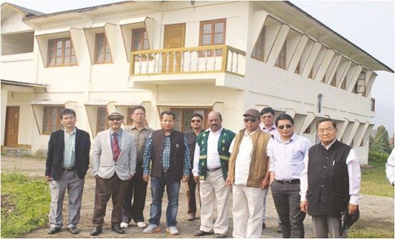
The team, which included state liaison officer Dr VN Sharma, held a meeting with ADC Emar Ete, HoDs, panchayat members, and people of the area, during which the public generally opined that academic activities of the college should begin at the earliest at its temporary site. As the construction work on the college is yet to start, the team, accompanied by PR leaders and HoDs, visited unused government buildings located in Basar. They inspected the double storied boy's hostel constructed by the PWD under SPA; the shopping complex-cum-working women's hostel; the tourist lodge constructed by the RWD; the Type V quarter constructed to accommodate the ADC; and other places. The HoDs also assured to provide ministerial staffs and accommodation facilities for teachers. On its visit to the permanent site of the college to assess the progress of work, the team found that the site development has been completed and that the construction of the academic block would start soon. On being informed by the site engineer that the exact area of the college is about 23.50 acres, Ete requested the local administration to acquire more land as the minimum required area for the model degree college is 30 acres. Later, the team visited the site for the proposed BEd College at Bogdo in Aalo.

Govt. Engg. College at Toru
ITANAGAR, Apr 1: The State Government’s persistent efforts to facilitate technical education to the students of the state at their door step yielded result as Union Ministry of Human Resources Development (MHRD) has approved for establishing a Government Engineering College at Toru under Papum Pare district.
Besides, the MHRD has sanctioned for upgrading Dera Natung Government College here and Jawaharlal Nehru College, Pasighat to Model Degree Colleges under Rashtriya Uchchatar Shiksha Abhiyan (RUSA) for which first instalment grants have already been earmarked, informed Education Minister Tapang Taloh.
Establishing a Government Engineering College in the state had been a long felt demand of people and I am glad that our efforts bore fruits,” a visibly happy Taloh said in a press release. He hoped the upcoming institute will cater the technical educational needs of the students of all categories.
“Thousands of students from the state go out of the state every year for pursuing higher and technical education which involves huge expenditure”, the Education Minister said. He hoped the new Govt. Engineering College would not only facilitate the students to get engineering degrees with meager financial involvement but also reduce economic burdens of poor parents, Taloh added.
The foundation stone for the college will be laid by Chief Minister Nabam Tuki at Toru on April 15, the release added.

CM lays foundation stone of Govt. Engineering College
ITANAGAR, Apr 16: Chief Minister Nabam Tuki yesterday laid the foundation stone of first Govt. Engineering College at Toru under Papum Pare district.
The Chief Minister Nabam Tuki while addressing the gathering said that it is the fruit of constant persuasions from the state Govt to set up an engineering college of its own in the state as due to non existence of higher technical college every year thousands of students moves out to other states for seeking higher technical education and many could not pursue due to financial constraints. But with the coming up of Govt Engineering college wish of many students will be fulfilled to study in their own state, he added.
Emphasizing on maintaining design and concepts as per the geographical needs of the area Tuki said that it should be a model college and it should be an epitome of centre of excellence learning for technical education.
Education Minister Tapang Taloh congratulated the people and expressed his immense happiness over coming up of first Govt Engineering College at Toru and said it was a dream come true project to facilitates the higher technical education in our own state. Lauding the people of Toru circle and land donors for their support and co-operation, he appealed them to always co-operate the executing authority for successful execution of works so that all works can be completed in stipulated time, while saying so he also asked the executing agency to strictly adhere to quality of work and design. He informed that college is set up under the Govt of India project called RUSA –Rashtriya Uchchtar Shiksa Abhiyaan to promote higher technical education in remote areas.
AMont others Speaker Nabam Rebia, Home Minister Tanga Byaling, Parliamentary Secretaries Bamang Felix, Alo Libang, Gum Tayeng, Karya Bagang, ZPC Nabam Aka, Chief Secretary Ramesh Negi, Secretary Education R.K. Mishra, Secretary IPR and Youths and Sports Dani Sulu, Secretary Planning Sonam Chombey, Director Higher Technical Education Dr.Tejum Padu, Director School Education Tapang Taloh, Director Elementary Education Bodong Yirang, Project Director GIZ Germany and Director DoNER Mercy Epao, Ex. MLA Tani Loffa, DC Tai Kaye and SP P.N Khrimey, all head of departments, officers of DHTE, panchayat leaders, GBs and general public attended the ceremony.

State’s responsibility to provide the best to students: Taloh
Review of RUSA

ITANAGAR, Aug 1: “Students are the future of the nation and it is our responsibility to provide them with the best of facilities,” said Education Minister Tapang Taloh.
Speaking during a day-long workshop on the implementation of the Rashtriya Uchchatar Shiksha Abhiyaan (RUSA) at the institutional level across the state, Taloh said the government has to enable students to face the challenges of the world. Taloh, who is also the chairman of the state higher education council, said the state has come a long way in the field of higher education. “In 1964, the state had just one higher education institute – Jawaharlal Nehru College (JNC) in Pasighat. Now we have more than 52 higher educational institutions,” he said.Although, compared to other states, Arunachal introduced RUSA late, “it is being implemented properly”, Taloh said. The minister informed that the Centre has sanctioned establishment of an engineering college in Toru; upgradation of JNC, Pasighat, and DNG College, Itanagar; and upgradation of infrastructure in Donyi Polo government college, Kamki and the government college in Bomdila under RUSA.“With the implementation of RUSA in the state, the financial burden on the state government has been significantly reduced,” he added. On the enrollment issue plaguing colleges in the state, Taloh said “there is need to evolve a proper mechanism to deal with the problem.”Concurring with the fact that not creating posts of non-teaching staff has been a big problem for college authorities, he disclosed that posts for non-teaching staff are likely to be sanctioned by the state government within 2-3 weeks. Earlier, RUSA chief consultant Simanta Mohanty from New Delhi said Arunachal Pradesh has accorded priority to higher education by implementing RUSA in 2014.“Under RUSA, the higher education in the state will be developed in a planned, systematic way with funds for infrastructure and upgradation of existing institutions,” he said. Board member, Central Advisory Board on Education (CABE) Dr Joram Begi, who is also the former higher & technical education director, in his keynote speech said while literacy and higher education have no connection, “higher education is connected to social status”. “If the needs of financial, quality and infrastructures of the higher educational institutes are not addressed, we’ll be producing an army of disgruntled people,” he said.Pointing out that many students are being deprived of access to higher education, he called for increasing the state’s dismal gross enrollment ratio (GER), which is currently around 19.04 per cent. Stating that “product itself possesses quality”, he further lamented that no Indian university has made it to the list of the top 200 universities of the world. “If you don’t have quality education, how can you realize the dream of a developed nation?” he questioned. Dr Begi also expressed concern at the present teacher-student ratio, which is around 1:56.5 in most of the government colleges in the state.The state government and the education department must implement RUSA not only for quality education but to tide over the manpower and resource crunch faced by most of the colleges, he said. “With the implementation of RUSA in the country in 2013, the path for further development of higher education in the state has been laid,” said higher and technical education director Dr Tejum Padu. He exuded hope that under RUSA “our higher educational institutions will only benefit”. RUSA deputy project director Minto Ete also spoke. It may be mentioned here that RUSA is a centrally sponsored scheme launched in 2013. It aims to provide strategic funding to eligible state higher education institutions with the objective of improving overall quality of education.

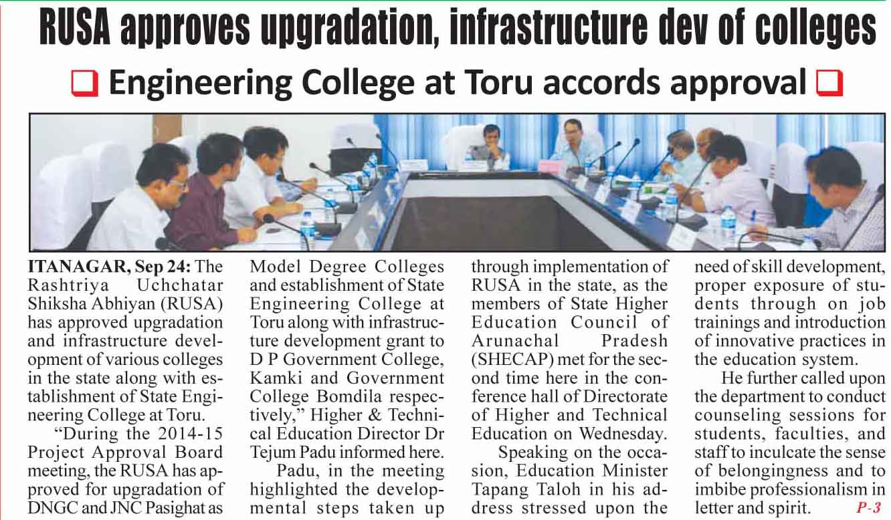
Archive from: Sunday 15th of November 2015

RUSA team inspect colleges
TDP NEWS DESK, ITANAGAR, Nov 14, 2015: A Rashtriya Uchchatar Shiksha Abhiyan (RUSA) team recently inspected various colleges in the state. The team which included RUSA consultant New Delhi Chani Raj, RUSA deputy state project director Minto Ete, officer on special duty Joram Muthu and others inspected Dera Natung Government College, Itanagar and government colleges at Seppa and Bomdila.
In Dera Natung Government College, the team interacted with the principal and RUSA coordinator. They advised the college authority to implement the RUSA programme sincerely. The team also inspected the newly constructed information centre and security room. The centre and security room has been constructed at an estimated cost of Rs 8 lakhs. The team also inspected the under construction commerce block, which is being taken up at an estimated cost of Rs 100 lakhs. It may be mentioned that four classrooms along with professor’s rooms and washrooms (for boys and girls students) in each floor is under construction, in addition to the upgradation of the commerce block under RUSA programme. The team urged the executing department and the college authorities to complete the work as per schedule and submit the utilization certificate for release of the installment amount. In Seppa, the RUSA team inspected the permanent site of the government model degree college, Seppa. During the interaction with the RUSA team, the officials of the executing department informed that due to halt in fund flow, construction of academic and administrative blocks have been stopped. Officials informed the visiting team that the amount released under model degree college scheme amounting to Rs 200 lakhs has already been used. Later, interacting with college principal and RUSA coordinator at government college Seppa, the RUSA team urged them to use funds judiciously and in a transparent manner. In Bomdila, the RUSA team inspected the new campus of the college. The team inspected the new infrastructures like girls hostel, boys hostel and quarters etc. The officials of the executing department informed the team that construction of the academic block has already started and construction of six additional classrooms will be taken up immediately at an estimated cost of Rs 70 lakhs from RUSA funds under renovation/upgradation of infrastructures.

Archive from: Thursday 28th of January 2016

RUSA DSPD inspects ongoing work at colleges
AALO, Jan 27, 2016: Rashtriya Uchhattar Shiksha Abhiyan (RUSA) deputy state project director (DSPD) Minto Ete visited Donyi Polo government college in Kamki and model degree college in Basar, in West Siang district, recently to monitor the implementation of RUSA projects there. On Monday, Ete interacted with DPGC principal Dr Rejir Karlo and RUSA coordinator Nyade Nomuk. He expressed satisfaction over the quality of work done by the executing agency in the construction of additional classrooms under RUSA.
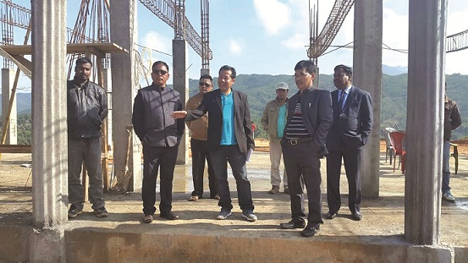
He, however, lamented lack of a proper office room for the RUSA cell in the college.
The visiting official also inspected the classrooms and other facilities in the campus, and held discussions about the extension of classrooms, administrative block, etc. Dr Karlo emphasized the need for more faculty members and creation of infrastructure. He said there is a shortfall of about 15 to 20 faculty members in the college, saying that at present there are only 28 in the college, including those for the commerce stream. He informed that the present administrative block, constructed under the MPLAD fund in March 2001, is a guest house. The principal also informed that the biggest bottleneck facing the college is surface communication, adding that the V-Sat in the campus is also not functioning properly. On Tuesday, Ete inspected the ongoing construction activities at the model degree college in Basar. Interacting with the executing officials there, he expressed satisfaction over the quality of work, and requested the executing agency, PWD, to maintain quality. Zilla parishad member Basar Jonya Basar urged Ete to impress upon the government for immediate release of Rs 10 crores under the central relief fund (CRF) for demarcation of a boundary and construction of boundary walls. He said the construction activities at the academic block were going on smoothly and in good pace. Basar meanwhile asked the PHE&WS and the power departments to ensure proper supply of water and electricity at the construction site.

Sites inspected for college, polytechnic in Tawang
May 15, 2016
ITANAGAR, May 14: A team of officers from Directorate of Higher and Technical Education and RUSA (Rashtriya Ucchchattar Shiksha Abhiyaan) inspected sites for establishment of a Government College and a Polytechnic in Tawang recently.
While interacting with the people at Tawang, Director, Higher & Technical Education Dr. Tejum Padu appealed to the people to extend full cooperation in the establishment of the educational intitutions. Parliamentary Secretary (Education) Tsering Tashi accompanied the team.
Earlier, Dr. Padu and his team inspected the academic block, hostels and querters of the Govt. Polytechnic at Dirang.
Interecting with the Principal of the Polytechnic, the team advised for best utilisation of the limited assets created so far. Dr. Padu also instructed the students to be sincere and dedicated in their study. He assured to extend all possible help from the Directorate for growth and development of the polytechnic.
In Govt. College, Bomdila, the team inspected all the buildings that have been constructed in the new college campus.
While interacting with the executing agency, the Director of Higher & Technical Education requested it to maintain quality in the construction of academic block. The team also inspected the IT items procured from RUSA fund in the old campus of the college.
It was a routine inspection and monitoring of various ongoing construction activities in the colleges and ploytechnics as well as to study the feasibility for establishment of a College and a Polytechnic in Tawang district.
Othe members of the team were Deputy Director of Higher & Technical Education A Jongkey and Deputy State Project Director, RUSA Minto Ete. The tour was conducted from May 9 to 13.

‘Developmental works should be planned to meet the future requirements’
August 21, 2016
ITANAGAR, Aug 20: Director of Higher and Technical Education cum SPD (RUSA) Dr. Tejum Padu said that developmental works should be planned in such a way that they cater to the future requirements.
Inaugurating a day-long workshop on Geo-tagging, PFMS, SLQAC and AISHE conducted by State Project Directorate, Rashtriya Uchchatar Shiksa Abhiyan, Rajya Mission at APSCTE Conference Hall, DHTE here on Saturday, Padu said that after implementation of Tech. Ed.-III project, many a pass-out students will not only be holding the key positions in various organizations but they will also be participating in entrepreneurial activities thereby contributing to the development of the state.
He opined that the charter of duties of the staff must be kept rotational in order to inculcate the proper learning and understanding of all the activities so that in absentia of any staff, work should not be hampered.
Deputy SPD (RUSA) Minto Ete called upon all the RUSA Coordinators and Principals of 13 Govt. Colleges of the State for strict monitoring of the developmental and other works executed under RUSA for the betterment of the Institutions.
He said that Institutes are the real implementers of the RUSA programmes and schemes and the Directorate is only a facilitator. He also stressed upon equipping all the faculties and stakeholders with Information and Communication Technology tools.
During Technical Session-I, Ete presented about the Bhuvan RUSA App which is a geo-tagging reporting tool for various parameters, like new construction, up-gradation works and equipments. This mobile App is a platform for controlled crowd sourcing to build spatial database on Bhuvan Geo-platform.
He further presented about the Central Plan Scheme Monitoring System implemented by the Comptroller General of the Accounts in collaboration with the NIC. It comprises direct payment to beneficiaries both under selected plan and non-plan schemes. CPSMS is linked with NPCI and provide immediate validation of bank accounts thus the e-disbursement of the benefits.
The Dy. SPD informed that it has become mandatory for all the institutions to register under Know Your College (KYC) under AISHE. He briefed the various activities conducted under RUSA and informed about the areas in which the institutions are eligible to receive financial support. He also requested all the stakeholders to extend cooperation for successful implementation of RUSA flagship programme in the State.
Dr. VN Sharma, SLO, highlighted about the activities conducted under State Level Quality Assurance Cell (SLQAC) for enhancing the quality of education and to inculcate best practices among the institutions. He called upon all the principals and coordinators to record and report all the activities carried out by the institutions for enhancing conduciveness of teaching learning atmosphere.
He also highlighted on SLQAC and All India Survey on Higher Education (AISHE) initiated by the MHRD in 2011 to build a robust database and to assess the correct picture of Higher Education in the country. The institution has to register on portal to fill in Data Capture Formats.

Workshop on Geo-tagging held
August 21, 2016 Archive No comments
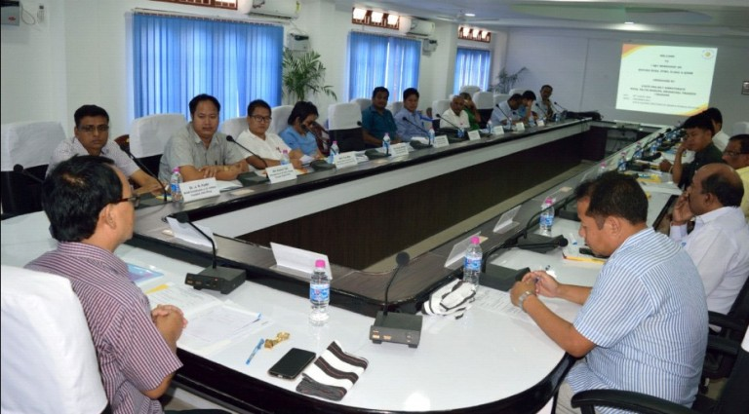
Itanagar, Aug 20: A one-day workshop on Geo-tagging, PFMS, SLQAC and AISHE conducted by the State Project Directorate, Rashtriya Uchchatar Shiksa Abhiyan (RUSA), Rajya Mission was held at the APSCTE conference hall at the Directorate of Higher & Technical Education here today.
Higher & Technical Education Director cum State Project Director (RUSA) Dr Tejum Padu inaugurating the day-long workshop said that developmental works should be planned in such a way that they cater to the requirements of the future.
He also said that after implementation of Technician Education-III project many a pass-out students are holding not only key positions in various organizations but also participated in entrepreneurial activities thereby contributing for the development of the State.
He opined that the charter of duties of the staff must be kept rotational in order to inculcate the proper learning and understanding of all the activities so that in absentia of any staff, work shall not be hampered.
Earlier, Dy SPD (RUSA) Minto Ete, while delivering the welcome speech, stressed on equipping all the faculties and stakeholders with information and communication technology tools to cope up with the development.
Asserting that educational institutions were the real implementers of the RUSA programmes with the Directorate being only a facilitator, he called upon all the RUSA coordinators and principals of all 13 govt colleges of the State for strict monitoring of the developmental and other works executed under RUSA for the betterment of the institutions.
In technical session-I, the Dy SPD (RUSA) presented the Bhuvan RUSA App which is a geo-tagging reporting tool for various parameters like new construction, upgradation works and equipments. This mobile App is a platform for controlled crowd sourcing to build spatial database on Bhuvan Geo-platform.
He further gave a presentation about the Central Plan Scheme Monitoring System (CPSMS) implemented by the Controller General of the Accounts in collaboration with the NIC. It comprises of the direct payment to beneficiaries both under selected plan and non-plan schemes. CPSMS is linked with NPCI and provides immediate validation of bank accounts thus the e-disbursement of the benefits.
In technical session-II, Dr V N Sharma, SLO talked about the activities conducted under State Level Quality Assurance Cell (SLQAC) for enhancing the quality of education and to inculcate best practices among the institutions. He called upon all the principals and coordinators to record and report all the activities carried out by the institutions for enhancing conduciveness of teaching-learning atmosphere.
He also made a presentation on All India Survey on Higher Education (AISHE) initiated by the MHRD in 2011 to build a robust database and to assess the correct picture of higher education in the country. The institutions have to register on portal to fill in data capture formats.
During the open house session, the Dy SPD informed that it has become mandatory for all the institutions to register under Know Your College (KYC) under AISHE. He briefed the various activities conducted under RUSA and informed about the areas in which the institutions are eligible to receive financial support. He also requested all the stakeholders to extend cooperation for successful implementation of RUSA flagship programme in the State.

