MIZORAM STATE HIGHER EDUCATION PLAN AT A GLANCE
UNDER RASHTRIYA UCHCHATAR SHIKSA ABHIYAN (RUSA)
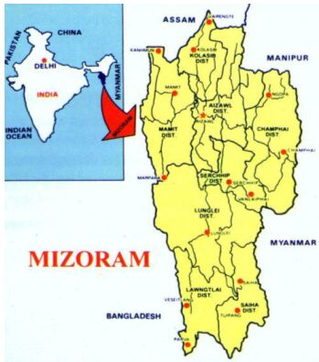

STATE PLAN AT A GLANCE IN DATA CAPTURING FORMAT (DCF)

SUBMITTED TO MINISTRY OF HUMAN RESOURCE DEVELOPMENT GOVERNMENT OF INDIA, NEW DELHI

